**Introduction**

Fruits and vegetables are important constituents of our diet and they serve as a vehicle of nutrients like vitamins, minerals, sugars, and fiber. However, being harvested from farm or field they are prone to contain dirt, soil, bacterial contamination, and extraneous matter making them unfit for direct consumption by consumers. Hence, processing interventions are necessary to make fruits and vegetables free from all the above mentioned materials. Also, their processing is required to increase their shelf life as well as to prepare a number of value added products from them. Fruits and vegetables are processed by various methods like low temperature, thermal treatment, concentration, freezing and irradiation. But prior to subjecting fruits and vegetables to such treatments, all fruits and vegetables undergo some preliminary operations. Each processing method is based on certain principles and each has its own advantages and disadvantages.

**8.2  Post Harvest Preliminary Processing Operations**

The preliminary processing operations of fruits and vegetables are sorting, grading, washing, peeling, sizing, blanching, etc. The importance of each operation is discussed below.

**8.2.1  Sorting and grading**

Sorting and grading are terms which are frequently used interchangeably in the food processing industry, but strictly speaking they are distinct operations. Sorting is a separation based on a individual physical properties of raw materials such as weight, size, shape, density, photometric property, etc. while grading is classification based on quality incorporating commercial value, end use and official standards. The selection of fruits and vegetables is important from processing point of view for the manufacture a particular end product. The fruit should be ripe, but firm and evenly matured while vegetable should be tender and reasonably free from soil, dirt, etc. They should be free from blemishes, insect damage, and malformation. Overripe fruit is generally infected with microorganisms and would yield a poor-quality finished product. After this preliminary sorting, the fruits and vegetables are graded. This is necessary to obtain a pack of uniform quality as regards size, color, etc. It is done manually or with the help of grading machines.

**8.2.2  Washing**

The graded fruits and vegetables are washed with water in different ways, such as soaking and subsequent washing in running water or sprayed with water or dry air to remove surface adhering material. A thorough wash is very essential for improved microbiological quality of final product. Vegetables may preferably be soaked in a dilute solution (0.1%) of potassium permanganate or sodium hypochlorite solution to disinfect them. Agitation of the washing water is effected generally by means of compressed air or a force pump or propeller-type equipment. Among all, spray washing is the most efficient method.

**8.2.3  Size reduction**

Fruits and vegetables are processed either as whole or into small pieces by size reduction. Size reduction involves peeling, coring and sizing. Peeling is done to remove unwanted or inedible material and to improve the appearance of the final product using a peeler (Fig. 8.1) while coring is done to remove central inedible portion using a corer (Fig. 8.2). There are five main methods of peeling. They are flash peeling (e.g. for root crops), knife peeling (e.g. for citrus fruits), abrasion peeling (e.g. for potato), caustic peeling (e.g. for guava, orange segments) and flame peeling (e.g. onion and garlic). Some of these are given below:

***a.  Hand peeling***

Many of the fruits and vegetables are peeled and cut by hand with the help of special knives.

***b.  Peeling by heat***

Some fruits and vegetables, particularly certain varieties of peaches and potatoes, are scalded in steam or boiling water to soften and loosen the skin, which is subsequently removed easily by hand. It usually involves exposing the fruit or vegetable to a temperature of 40�C for 10-60 seconds where by the skin bursts and retracts facilitating its easy removal by means of pressure sprays. To achieve good results, the fruits and vegetables should be of uniform size and maturity. Using this method, there is practically no loss of flavour and the product is of uniform colour, free from any blemishes.

***c.  Lye peeling***

Fruits and vegetables such as peaches, apricots, sweet orange, carrots, sweet potatoes, etc. are generally peeled by dipping them in boiling caustic soda or lye solution of 1 to 2 percent strength, for short periods, ranging from 0.5 to 2 minutes depending on the maturity of the fruit or vegetable. The hot lye loosens the skin from the flesh underneath. The peel is then removed easily by hand. Any traces of alkali is removed by washing the fruit or vegetable thoroughly in running cold water or preferably by dipping it for a few seconds in a very weak solution of hydrochloric or citric acid.

***d.  Flame peeling***

It is used only for garlic and onion which have a papery outer covering. This is just burnt off.

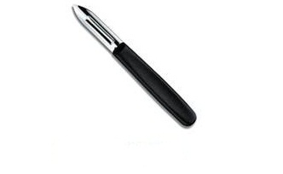

**Fig. 8.1 Pineapple corer and its use**

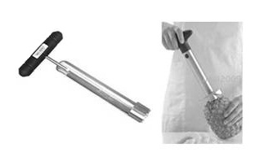

**Fig. 8.2 Pineapple corer and its use**

**8.2.4 Blanching**

Blanching refers to the mild heat treatment given to fresh produce such as vegetables to inactivate enzymes. Polyphenol Peroxidase (PPO) is most important groups of enzymes causing browning, off-flavour development in fruits and vegetables. PPO cause oxidation of phenolic compound namely Catechin, Gallic acid, Chlorogenic acid and Caffeic acids. Besides PPO certain peroxidase and pectic enzymes are also require inactivation. Pectic enzymes such as Pectin methyl esterase (PME) and Polygalacturonase (PG) are highly meat resistance and if failed to inactivate may lead to loss of cloud in citrus juices and serum separation in fruits and vegetables products, respectively.  Their inactivation is the index of blanching. Blanching also improves color, flavour and nutritional quality. Usually, it is done with boiling water or steam for short periods, followed by cooling. In small-scale industries, the fruit or vegetable to be blanched is placed in a wire of a perforated basket, which is first dipped in hot water (88-99C) for about 2-5 minutes. Microwave treatment is also used for blanching. Blanching requirement varies with different fruit or vegetable and depends upon relative enzyme concentration and maturity of commodity.

**8.2.5  Ripening**

Ripening before processing may be required for certain fruits such as avocado, banana, kiwifruit, mango, nectarine, papaya, peach, pear, plum, melons, etc. that are picked immature. Ethylene treatment can be used to obtain faster and more uniform ripening. The optimum temperature range for ripening is 15-25�C and within this range, the higher the temperature the faster the ripening. Relative humidity should be maintained between 90 and 95% during ripening. About 10 ppm ethylene in enclosed chamber is sufficient to initiate ripening. Ethylene is produced by the reaction between calcium carbide with moisture, mainly those involved in trade of fruits to hasten the ripening process. However, indiscriminate application may pose serious health hazards. Commercially ethephon is used for the pre-harvest ripening of top fruits, soft fruits, tomatoes and coffee. It is also used to facilitate the harvest of fruit and berry crops (by loosening the fruits) and to accelerate post-harvest ripening. It is essentially a plant growth regulator with systemic properties. It penetrates into the tissues and is translocated. It decomposes into ethylene which is the active metabolite.

**Introduction**

Fruits and vegetables are the most perishable commodities and are important ingredients in the human dietaries. Fruits and vegetables are seasonal in nature and prices go down considerably during the glut period and production becomes uneconomical due to distress sale. Thus an increase in production of fruits and vegetables will have little value if the produce is not properly handled, processed or utilized. The costs involved in preventing the losses are always cheaper that the cost of production; hence, processing receives greater attention in recent years.

 The fruits and vegetable processing industry in India is highly unorganized. The prominent proceeds items are fruit pulps and juice, fruit based ready–to-serve beverages, canned fruits and vegetables, jams, squashes, pickles, chutneys, dehydrated vegetables, etc. More recently, products like frozen pulps and vegetables, frozen dried fruits and vegetables, fruit juice concentrates and vegetable curries in restorable pouches, canned mushroom and mushroom products have also been taken up for manufacture by the industry. In real life situations, preservation effects complex involving methods such as physical, physicochemical, chemical and biochemical phenomena and these phenomena never work in isolation. Following paragraphs explains certain well established processes for preservation of fruits and vegetable, the equipments required and other details for a fruit and vegetables processing unit.

 8**.1 Freezing**

Freezing is a low temperature preservation process where the product is frozen at -38 0C and stored -18 0C. Freezing is cheaper than canning and frozen products are close to fresh products and of better quality the metabolic activity and spoilage due to post harvest chemical are retarded by freezing. Through the product preserved by freezing retains their quality appreciably, the major disadvantage of the process is that the low temperature has been maintained during handling, transportation and storage before the product is finally consumed. Suitable fruits and vegetables for freezing are mango slices, pulp, pineapple slices, guava slices, orange segments, peas, carrot, cauliflower, beans, etc.

 When compared to the most other food preservation methods, freezing requires the least amount of food preparation before storage and under optimum conditions it has the best nutrient, flavour, and texture retention. Since food remains microbiologically safe during freezing, its shelf life is determined by chemical and physical changes that occur during storage.

 IQF refers to Individual Quick Freezing of every particle/aggregate using fluidization in a stream of very cold air. Fluidization leads to high heat transfer co-efficient and therefore very rapid freezing and hence better quality. For example, freezing of green peas in an air blast freezer may take 3-4 h whereas it is only 10-12 min by IQF. This results in for better texture and there is no humb or block formation. Some of other important IQF products are frozen fruit dices and cut vegetables.

**Equipments of freezing**

1) Freezer/cold room

2) Quick freezing Equipments- fluidized bed freezer, automatic package freezer, continuous plate freezer, continuous can freezer

3) Direct Immersion equipments- Brine Freezer, Frog freezer, and Bartlett freezer

4) Rotating cold drum

5) Foot operated polythene bag sealer- sealing polyethylene bags of different gauges after filling of fruits and vegetables

**Methods of freezing**

i) Quick (0 to -40 0C for 30 min.)

ii) Sharp (-15 to -29 0C for 3-72 h)

iii) Cryogenic (-196 0C)

iv) Dehydro-freeing (50 % moisture removed)

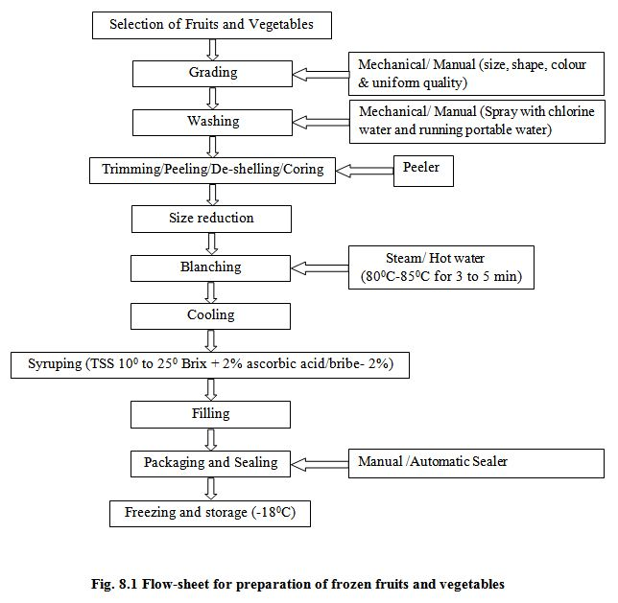

**8.2 Dehydration**

Dehydration is the removal of moisture from fruits and vegetables by artificially produced heat under controlled condition of temperature, relative humidity and air flow. In dehydration, sufficient moisture is removed so that the product is free from spoilage; but this must be done in such a way to preserve food value as far as possible. Rate of dehydration is so done in hygienic condition to have products of uniform colour than sun dried. Dehydration reduces the bulk, requires less storage space and usually cheaper that the other methods of preservation. The suitable fruits and vegetables for dehydration are grape, date, fig, raw mango, anola, ber, litchi, apricot, banana, apple, carrot, leafy vegetables, etc. FPO specification for dehydrated fruits and vegetables are;

 1) Moisture content shall not exceed 20 per cent and 24 per cent (w/w) respectively.

2) Fruits and vegetables used for drying be clean, wholesome and shall be practically free from insect or fungal attack.

3) Dehydrated products may contain permitted preservations.

**Equipments used for Dehydration**

**Blanching unit:** It can be used for pre-treatment (steam blanching) of fruits and vegetables before processing.

**Types of dryers used:** Kiln drier- pieces; Cabinet/tray drier- pieces; purees, liquids; tunnel- pieces; continuous conveyer belt-purees, liquids; Belt trough-pieces; air lift- granules; spray- liquid; vacuum-purees, liquid, pieces; Fluidized bed-small pieces; Drum or roller-Liquid, purees.

**Vacuum drier-** It is used for dehydration of fruits and vegetables without any change in sensory attributes.

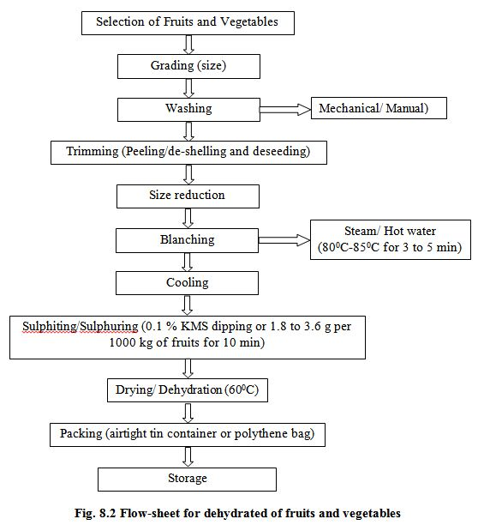

**8.3 Canning**

Canning is a method of food preservation. Canning may be defined as heating and sealing of food material in a hermetically sealed container.

**a) Fruit Canning:** The most important fruits for canning are mango, pineapple, guava, litchi, cherry. Strawberry, jackfruit, etc.

**Specification**

- The head space in the can shall not be more than 1.6 cm.

- The drained weight of the fruit shall not be less than 50 per cent and fruit should be firm

- No preservative shall be added

- No artificial colour shall be present

- The can shall not show any positive pressure at sea level and shall not show any sign of bacterial growth when included at 37 0C for a week.

**Equipments required for canning**

- Fruit cutter/ slicer

- Blancher (water/steam)

- Canning equipments (double seamer, flanger, can reformer)

- Retorting equipment

- Can opener

- Exhaust Unit

- Canning material (Tin plate can, Aluminium can, TFS can)

**b) Vegetable Canning:**In vegetable canning, the specific requirements for brine strength, exhaust, processing temperature, time and types of cans, etc., are needed. Suitable vegetables for canning are cauliflower, carrot, peas, okra, beans, cabbage, etc. Mushrooms can also be canned.

**Specifications**

- The head space in the can shall not be more than the 1.6 cm.

- The drained weight of preservative of the vegetables shall not be less than 55 percent except in tomato (50%)

- No addition of preservative and no artificial colour shall be present except in the case of peas.

- The can shall not show any sign of bacterial growth when incubated at 370C for a week.

**Process of Canning**

**1) Selection of fruits and vegetables**

i)   Fruits and vegetables should be absolutely fresh.

ii) Fruits should be ripe, but firm, and uniformly mature. Over-ripe fruits should be rejected  because they are infected with microorganisms and give a poor quality product.

      Unripe fruits should be rejected because they generally shrivel and toughen on canning.

iii) All vegetables except tomatoes should be tender.

iv)Tomatoes should be firm, fully ripe and of deep red colour.

v)  Fruits and vegetables should be free from dirt.

vi) They should be free from blemishes, insect damage or mechanical injury.

**2) Grading:**

The selected fruits and vegetables are graded according to size and colour to obtain uniform quality. This is done by hand or by machines such as screw grader and roller grader. Fruits like berries, plums and cherries are graded whole, while peaches, pears, apricots, mangoes, pineapples, etc., are generally graded after cutting into pieces or slices.

**3) Washing:**

It is important to remove pesticide spray residue and dust from fruits and vegetables. One gram of soil contains 1012 spores of microorganisms. Therefore, removal of microorganisms by washing with water is essential. Fruits and vegetables can be washed in different ways. Root crops that loosen in soil are washed by soaking in water containing 25 to 50 ppm chlorine (as detergent). Other methods of washing are spray washing, steam washing, etc.

**4) Peeling:**The objective of peeling is to remove the outer layer. Peeling may be done in various ways. (hand peeling, steam peeling, mechanical peeling, lye peeling, flame peeling).

**5) Cutting:**Pieces of the size required for canning are cut. Seed, stone and core are removed. Some fruits like plum from which the seeds cannot be taken out easily are canned whole.

**6) Blanching:**

It is also known as scalding, parboiling or precooking. Fruits are generally not blanched leaving the oxidizing enzyme system active. Sometimes fruit is plunged for a given time-from half to, say, five minutes, according to variety-into water at from 180 °F to 200 oF, and then immediately cooled by immersion in cold water. The object is to soften the texture and so enable a greater weight to be pressed into the container without damage to the individual fruit. Blanching is usually done in case of vegetables by exposing them to boiling water or steam for 2 to 5 minutes, followed by cooling. The extent of blanching varies with the toed. This brief heat treatment accomplishes the following:

 i) Inactivates most of the plant enzymes which cause toughness, discolouration (polyphenol oxidase). mustiness, off-flavour (peroxidase), softening and loss of nutritive value.

ii) Reduces the area of leafy vegetables such as spinach by shrinkage or wilting, making their packing easier.

iii) Removes tissue gases which reduce sulphides.

iv) Reduces the number of microorganisms by as much as 99%.

v) Enhances the green colour of vegetables such as peas, broccoli and spinach.

vi) Removes saponin in peas.

vii) Removes undesirable acids and astringent taste of the peel, and thus improves flavour.

viii) Removes the skin of vegetables such as beetroot and tomatoes which helps in their peeling.

**7) Cooling:**After blanching, the vegetables are dipped in cold water for better handling and keeping them in good condition.

**8) Filling:**

Before filling, cans are washed with hot water and sterilized but in developing countries these are subjected to a jet of steam to remove dust and foreign material. Automatic, large can-filling machines are used in advanced countries but choice grades of fruits are normally filled by hand to prevent bruising in India. Hand filling is the common practice. After filling, covering with syrup or brine is done and this process is called syruping or brining.

**9) Exhausting:**The process of removal of air from cans is known as exhausting. After filling and lidding or clinching, exhausting is essential. The major advantages of exhausting are as under:

 i)  Corrosion of the tinplate and pin holing during storage is avoided.

ii) Minimizes discolouration by preventing oxidation.

iii) Helps in better retention of vitamins particularly vitamin C.

iv) Prevents building of cans when stored in hot climate or at high altitude.

v) Reduces chemical reaction between the container and the contents.

vi) Prevents development of excessive pressure and strain during sterilization.

 Containers are exhausted either by heating or mechanically. The heat treatment method is generally used. The cans are passed through a tank of hot water at 82 to 87 °C or move on a belt through a covered steam box. In the water exhaust box, the cans are placed in such a manner that the level of water is 4-5 cm below their tops. The exhaust box is heated till the temperature of water reaches 82 to 100 0C and the centre of the can shows a temperature of about 79 °C. The time of exhausting varies from 6 to 1 a minutes, depending on the nature of the product. In the case of glass jars or bottles, vacuum closing machines are generally used. The bottles or jars are placed in a closed chamber in which a high vacuum is maintained.

 It is preferable to exhaust the cans at a lower temperature for a longer period to ensure uniform heating of the contents without softening them into pulp. Exhausting at high temperature should be avoided because. The higher the temperature, the more is the volume of water vapour formed, and consequently the greater the vacuum produced in the can.

**10) Sealing:**

Immediately after exhausting the cans are sealed airtight by means of a can sealer. In case of glass jars a rubber ring should be placed between the mouth of the jar and the lid, so that it can be sealed airtight. During sealing the temperature should not fall below 74 °C.

**11) Processing:**

Heating of foods for preserving is known as processing, however, in canning technology processing means heating or cooling of canned foods to inactivate bacteria. Many bacterial spores can be killed by either high or very low temperature.   Such drastic treatment, however, affects the quality of food. Processing time and temperature should be adequate to eliminate all bacterial growth. Moreover, over-cooking should be avoided as it spoils the flavour as well as the appearance of  the product. Almost all fruits and add vegetables can be processed satisfactorily at a temperature of 100 °C, i.e., in boiling water.The presence of acid retards the growth of bacteria and their spores. Further, they do not thrive in heavy sugar syrup which is normally used for canning of fruits. Vegetables (except the more acid ones like tomato and rhubarb) which are non-acid in nature, have a hard texture, and proximity to soil which may infect them with spore-bearing organisms are processed at higher temperatures of 115 to 121 0*C.*

The sourness of fruits and vegetables is due to their acid content (measured in pH) which has a great influence upon the destruction of microorganisms. The lower the pH the greater is the ease with which a product can be processed or sterilized. Fruits and vegetables can be classified into the following four groups according to their pH value

Bacterial spores can be more easily destroyed at pH 3.0 (fruits) than at pH 5.0 to 6.0 (vegetables, except tomato and rhubarb). Bacterial spores do not grow or germinate below. pH 4.5. Thus, a canned product having pH less than 4.5 can be processed in boiling water but a product with pH above 4.5 requires processing at 115 at 121 oCunder a pressure of 0.70 to 1.05 kg/cm2 (10 to 15 lb/sq inch). It is essential that the centre of the can should attain these high temperatures.

 The temperature and time of processing vary with the size of the can and the nature of the food: the larger the can, the greater is the processing time. The processing time 'for different canned fruits and vegetables is given in the tables Under 'Canning of Fruits' and 'Canning of Vegetables'. Fruits and acid vegetables are generally processed in open type cookers, continuous non-agitating cookers and continuous agitating cookers, while vegetables (non-acid) are processed under steam pressure in closed retorts known as automatic pressure cookers. In India, small vertical stationary retorts (frontispiece) are generally used for canned vegetable processing. The sealed cans are placed in the cookers, keeping the level of water 2.5 to 5.0 cm above the top of the cans. The cover of the cooker is then screwed down tightly and the cooker heated to the desired temperature. The period of sterilization (processing) should be counted from the time the water starts boiling. After heating for the required period the cooker is removed from the fire and the petcock is opened. When the pressure comes down to zero the cover is removed and the cans are taken out.

**12) Cooling:**After processing. The cans are cooled rapidly to about 39 °Cto stop the cooking process and to prevent stack-burning. Cooling is done by the following methods:

 i)  dipping or immersing the hot cans in tanks containing cold water;

ii) letting cold water into the pressure cooker specially in case of vegetables;

iii) Spraying cans with jets of cold water; and

iv) exposing the cans to air.

 Generally the first method, i.e., dipping the cans in cold water, is used. If canned products are not cooled immediately after processing, peaches and pears become dark in colour, tomatoes turn brownish and bitter in taste, peas become pulpy with cooked taste and many vegetables develop flat sour (become sour).

**13) Storage:**

After labeling the cans, they should be packed in strong wooden cases or corrugated cardboard cartons and stored in a cool and dry place. The outer surface of the cans should be dry as even small traces of moisture sometimes induce rusting. Storage of cans at high temperature should be avoided, as it shortens the shelf-life of the product and often leads to the formation of hydrogen swell. The marketable life of canned products varies according -to the type of raw materials used. Canned peach, grapefruit, pineapple, beans, spinach, pea etc., can be stored for about two years, while pear, apricot, carrot, beetroot, tomato, etc., can be stored for a comparatively short period only.

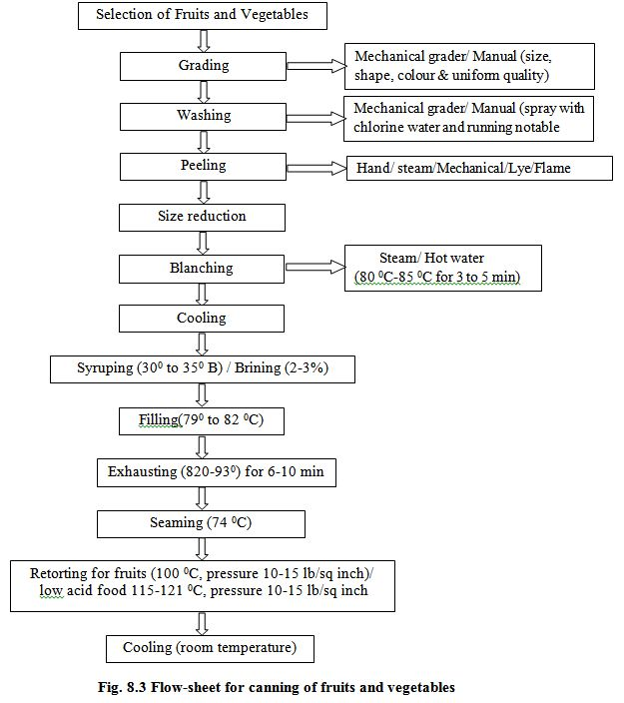

**Processed products of fruits and vegetables-**

The preservation of food in common salt is known as pickling. It is one of the most ancient methods of preserving vegetables. Pickles are good appetizers and add to the palatability of a meal. Mango pickle ranks first followed by cauliflower, onion, turnip and lime pickles. The growth of a majority of spoilage organisms is inhibited by brine containing 10-12 per cent salt. Pickling is the result of fermentation by lactic acid-forming bacteria" which are generally present in large numbers on the surface of fresh vegetables and fruits. Class I preservatives improves the taste and flavour and hardness of the tissue of vegetables and controls fermentations.

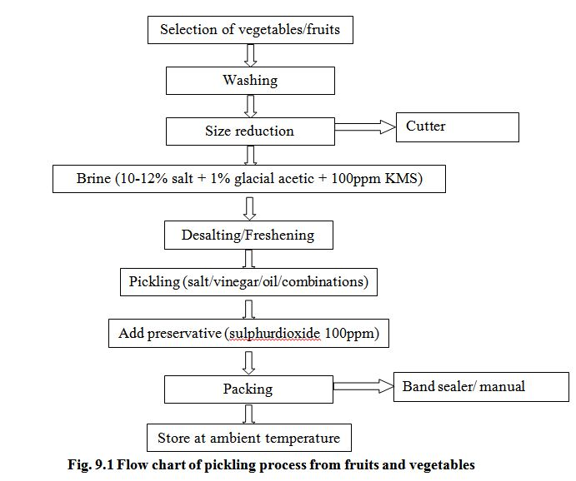

**9.2 Processing of Chutneys**

Good quality chutney should be palatable and appetizing. Mango chutney is an important food product exported from India to many countries. Apple and apricot chutneys are also very popular in the country. The method of preparation of chutney is similar to that for jam except that spices, vinegar and salt are added. The fruits/vegetables are peeled, sliced or grated, or cut into small pieces and cooked in water until they become sufficiently soft. The quality of chutney depends to a large extent on its cooking which should be done for a long time at a temperature below the boiling point. To ensure proper thickening, cooking is done without a lid even though this results in some loss of volatile oils from the spices. Chopped onion and garlic are added at the start to mellow their strong flavours. Spices are coarsely powdered before adding. Vinegar extract of spices may be used instead of whole spices. Spice and vinegar are added just before the final stage of cooking, because prolonged boiling cause loss of some of the essential oils of spices and of vinegar by volatilization.

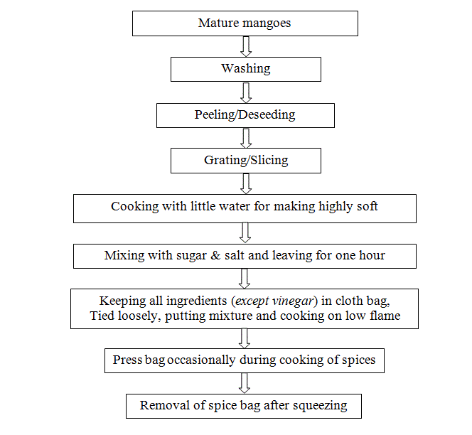

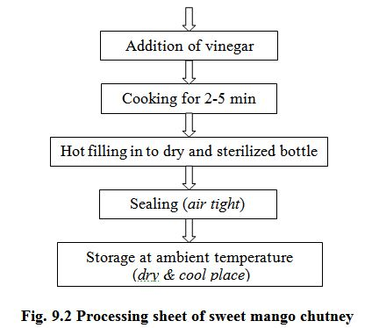

**9.3 Processing of Jam:**

Jam is a product obtained by cooking fruit pulp with sugar and acid to desired consistency. Jam contains 0.5-0.6 per cent acidity and 68 per cent total solids. Apple, pear, tomato, sapota, apricot, loquat, peach, papaya, karonda, carrot, plum, straw berry, raspberry, mango, tomato, grape and muskmelon are used for preparation of jams. It can be prepared from one kind of fruit or two or more kind.

i)  Machines and equipments made of stainless steel can be used for fruits and vegetables processing and preservation

ii)   SS steam jacketed kettle for cooking and concentration

iii) Fruit Pulpers- Brushes and SS sieves of various sizes are provided which are used for complete extraction from fruits.

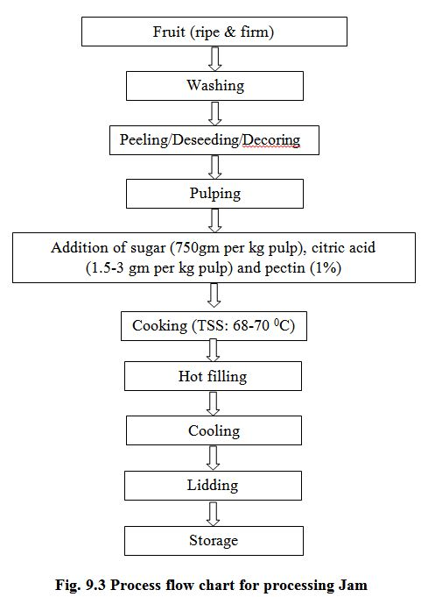

**9.4 Processing of Jelly:**Jelly is semi solid products obtained by boiling a clear, strained fruit juice with sugar and acid to a thick consistency, jelly total soluble solids not less than 65% and acidity 05-0.7 percent.

**9.4.1 Qualities of Jelly**

i)   Clear

ii)  Transparent

iii) Sparkling

iv) Attractive colour

v)  Keep its shape in which it is cut not breaking.

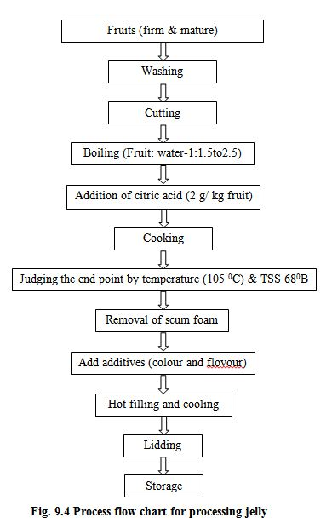

**9.5 Processing of Marmalade:**Marmalade is a fruit jelly in which peels are suspended. Marmalades are prepared usually from citrus fruits. The protein content of marmalade is slightly higher. FPO specification for marmalade area same as mentioned for jelly.

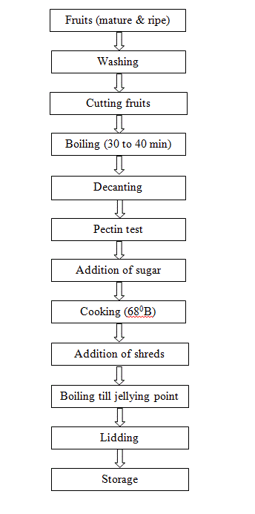**9.6 Processing of Murabba and Candy:**A mature fruit/ vegetable or its pieces impregnated with heavy sugar syrup till it becomes tends and transport is known as preserve or murabba.

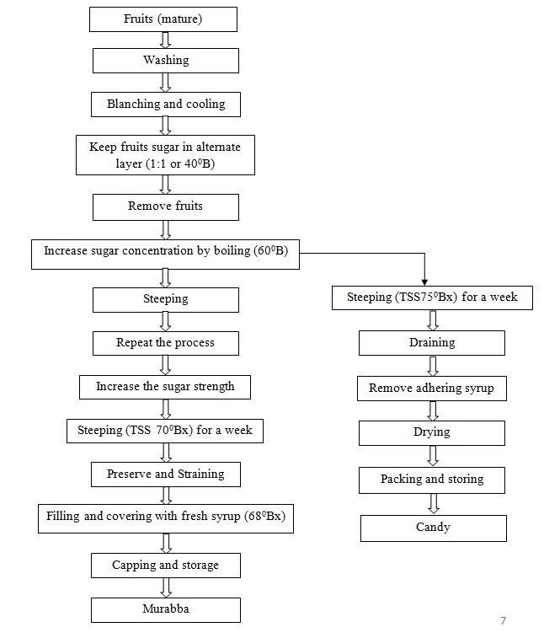

**9.7 Processing of Squash:**A type of fruit beverage which contains at least 25 percent juice and 45 percent total soluble solids is called as squash. It also contains about 1 percent acidity and 350 ppm sulphur dioxide or 600ppm sodium benzoate. It is diluted being served. Squash can be prepared from a wide variety of fruits of viz., mango, mandarin orange, lime, guava, anola, pineapple, papaya, bael, litchi, phalsa, jamun, pomegranate, plum, etc.

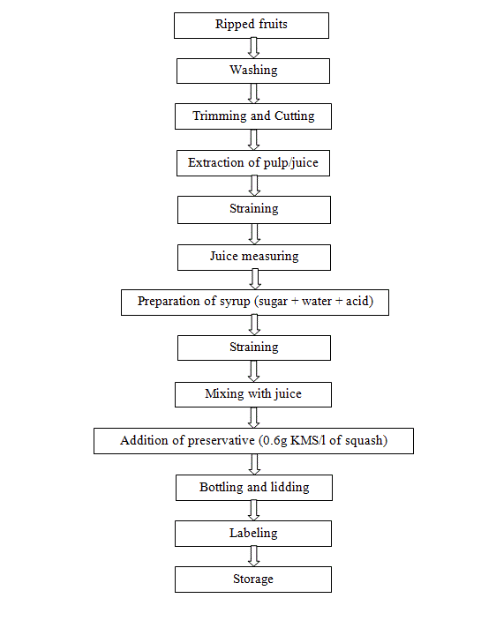

**9.8 Processing of Cordial:**Cordial is a sparkling clear sweetened fruit juice from which pulp and other suspended materials are completely eliminated. Cordial contains at least 25% fruit juice and 30% total soluble solids with 1.5% per cent acidity. Lime and lemons are most suitable fruits for preparation of cordial. This can also be prepared from other fruits as guava, grape, phalsa, etc.

**Specifications**

Minimum percentage of total soluble solids 30 and of fruit juice 25. The permissible limits of the preservative as sulphur dioxide or benzoic acid are same as mentioned for squash. The techniques used for preparation of cordial beverages area given under.

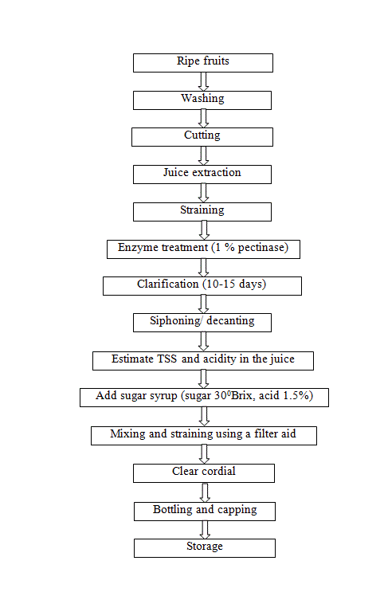

**9.9 Sauces and Ketchups:**

There is no essential difference between sauce and ketchup. However, sauces are generally thinner and contain more total solids (minimum 30%) than ketchups (minimum 28%). Tomato, apple, papaya, walnut, soybean, mushroom, etc., are used for making sauces.

Sauces are of two kinds: (i) *Thin*sauces of low viscosity consisting mainly of vinegar extract of flavoring materials like herbs and spices, and (ii) *Thick sauces*that are highly viscous.

Sauces/ketchups are prepared from more or less the same ingredients and in the same manner as chutney, except that the fruit or vegetable pulp or juice used is sieved after cooking to remove the skin, seeds and stalks of fruits, vegetables and spices and to give a smooth consistency to the final product. However, cooking takes longer because fine pulp or juice is used.

**Tomato puree and paste:**Tomato pulp without skin or seeds, with or without added salt, and containing not less than 9.0 per cent of salt-free tomato solids, is known as 'medium tomato puree'. It can be concentrated further to 'heavy tomato puree' which contains not less than 12 per cent solids. If this is further concentrated so that it contains not less than 25 per cent tomato solids, it is known as tomato paste. On further concentration to33 per cent or more of solids, it is called concentrated tomato paste. Tomato pulp is prepared from ripe tomatoes in the same manner as tomato juice. Cooking for concentration of the pulp can be done either in an open cooker or a vacuum pan. In the former most of the vitamins are destroyed and the product become brown. On the other hand, use of vacuum pans, which are expensive, help to preserve the nutrients and also reduce the browning to a great extent. In vacuum pans the juice is boiled at about 71°C only. Ordinarily tomato juice can be concentrated to 14-15 per cent solids in an open cooker, but for obtaining higher concentrations a vacuum pan is required. Moreover, sterilization of the product is also possible in a vacuum pan. While cooking in an open cooker, a little butter or edible oil is added to prevent foaming, burning and sticking. If, after cooking, the total solids content of the juice is higher. Than required, more juice is added to lower it, if it is lower, cooking is continued till the desired concentration is reached. The end-point of cooking puree and paste can be determined either with a hand refractometer or by measuring the volume (a known volume of juice is concentrated to a known volume of final product) with the help of a measuring stick.

**Tomato sauce/ketchup:**It is made from strained tomato juice or pulp and spices, salt, sugar and vinegar, with or without onion and garlic, and contains not less than 12 per cent tomato solids and 25 per cent total solids.

**9.10 Process of Canning**

**1) Selection of fruits and vegetables**

i) Fruits and vegetables should be absolutely fresh.

ii) Fruits should be ripe, but firm, and uniformly mature. Over-ripe fruits should be rejected  because they are infected with microorganisms and give a poor quality product.

      Unripe fruits should be rejected because they generally shrivel and toughen on canning.

iii) All vegetables except tomatoes should be tender.

iv)Tomatoes should be firm, fully ripe and of deep red colour.

v)  Fruits and vegetables should be free from dirt.

vi) They should be free from blemishes, insect damage or mechanical injury.

**2) Grading:**

The selected fruits and vegetables are graded according to size and colour to obtain uniform quality. This is done by hand or by machines such as screw grader and roller grader. Fruits like berries, plums and cherries are graded whole, while peaches, pears, apricots, mangoes, pineapples, etc., are generally graded after cutting into pieces or slices.

**3) Washing:**

It is important to remove pesticide spray residue and dust from fruits and vegetables. One gram of soil contains 1012 spores of microorganisms. Therefore, removal of microorganisms by washing with water is essential. Fruits and vegetables can be washed in different ways. Root crops that loosen in soil are washed by soaking in water containing 25 to 50 ppm chlorine (as detergent). Other methods of washing are spray washing, steam washing, etc.

**4) Peeling:**

The objective of peeling is to remove the outer layer. Peeling may be done in various ways. (hand peeling, steam peeling, mechanical peeling, lye peeling, flame peeling).

**5) Cutting:**

Pieces of the size required for canning are cut. Seed, stone and core are removed. Some fruits like plum from which the seeds cannot be taken out easily are canned whole.

**6) Blanching:**

It is also known as scalding, parboiling or precooking. Fruits are generally not blanched leaving the oxidizing enzyme system active. Sometimes fruit is plunged for a given time-from half to, say, five minutes, according to variety-into water at from 180°F to 200oF, and then immediately cooled by immersion in cold water. The object is to soften the texture and so enable a greater weight to be pressed into the container without damage to the individual fruit. Blanching is usually done in case of vegetables by exposing them to boiling water or steam for 2 to 5 minutes, followed by cooling. The extent of blanching varies with the toed. This brief heat treatment accomplishes the following:

 i) Inactivates most of the plant enzymes which cause toughness, discolouration (polyphenol oxidase). mustiness, off-flavour (peroxidase), softening and loss of nutritive value.

ii) Reduces the area of leafy vegetables such as spinach by shrinkage or wilting, making their packing easier.

iii) Removes tissue gases which reduce sulphides.

iv) Reduces the number of microorganisms by as much as 99%.

v) Enhances the green colour of vegetables such as peas, broccoli and spinach.

vi) Removes saponin in peas.

vii) Removes undesirable acids and astringent taste of the peel, and thus improves flavour.

viii) Removes the skin of vegetables such as beetroot and tomatoes which helps in their peeling.

**7) Cooling:**

After blanching, the vegetables are dipped in cold water for better handling and keeping them in good condition.

**8) Filling:**

Before filling, cans are washed with hot water and sterilized but in developing countries these are subjected to a jet of steam to remove dust and foreign material. Automatic, large can-filling machines are used in advanced countries but choice grades of fruits are normally filled by hand to prevent bruising in India. Hand filling is the common practice. After filling, covering with syrup or brine is done and this process is called syruping or brining.

**9) Exhausting:**

The process of removal of air from cans is known as exhausting. After filling and lidding or clinching, exhausting is essential. The major advantages of exhausting are as under:

 i) Corrosion of the tinplate and pin holing during storage is avoided.

ii) Minimizes discolouration by preventing oxidation.

iii) Helps in better retention of vitamins particularly vitamin C.

iv) Prevents building of cans when stored in hot climate or at high altitude.

v) Reduces chemical reaction between the container and the contents.

vi) Prevents development of excessive pressure and strain during sterilization.

 Containers are exhausted either by heating or mechanically. The heat treatment method is generally used. The cans are passed through a tank of hot water at 82 to 87°C or move on a belt through a covered steam box. In the water exhaust box, the cans are placed in such a manner that the level of water is 4-5 cm below their tops. The exhaust box is heated till the temperature of water reaches 82 to 1000c and the centre of the can shows a temperature of about 79°C. The time of exhausting varies from 6 to 1 a minutes, depending on the nature of the product. In the case of glass jars or bottles, vacuum closing machines are generally used. The bottles or jars are placed in a closed chamber in which a high vacuum is maintained.

 It is preferable to exhaust the cans at a lower temperature for a longer period to ensure uniform heating of the contents without softening them into pulp. Exhausting at high temperature should be avoided because. The higher the temperature, the more is the volume of water vapour formed, and consequently the greater the vacuum produced in the can.

**10) Sealing:**

Immediately after exhausting the cans are sealed airtight by means of a can sealer.

In case of glass jars a rubber ring should be placed between the mouth of the jar and the lid, so that it can be sealed airtight. During sealing the temperature should not fall below 74°C.

**11) Processing:**

Heating of foods for preserving is known as processing, however, in canning technology processing means heating or cooling of canned foods to inactivate bacteria. Many bacterial spores can be killed by either high or very low temperature. Such drastic treatment, however, affects the quality of food. Processing time and temperature should be adequate to eliminate all bacterial growth. Moreover, over-cooking should be avoided as it spoils the flavour as well as the appearance of the product. Almost all fruits and add vegetables can be processed satisfactorily at a temperature of 100°C, i.e., in boiling water.

 The presence of acid retards the growth of bacteria and their spores. Further, they do not thrive in heavy sugar syrup which is normally used for canning of fruits. Vegetables (except the more acid ones like tomato and rhubarb) which are non-acid in nature, have a hard texture, and proximity to soil which may infect them with spore-bearing organisms are processed at higher temperatures of 115 to 1210*C.*

The sourness of fruits and vegetables is due to their acid content (measured in pH) which has a great influence upon the destruction of microorganisms. The lower the pH the greater is the ease with which a product can be processed or sterilized. Fruits and vegetables can be classified into the following four groups according to their pH value.

 Bacterial spores can be more easily destroyed at pH 3.0 (fruits) than at pH 5.0 to 6.0 (vegetables, except tomato and rhubarb). Bacterial spores do not grow or germinate below. pH 4.5. Thus, a canned product having pH less than 4.5 can be processed in boiling water but a product with pH above 4.5 requires processing at 115 at 121oCunder a pressure of 0.70 to 1.05 kg/cm2 (10 to 15 lb/sq inch). It is essential that the centre of the can should attain these high temperatures.

 The temperature and time of processing vary with the size of the can and the nature of the food: the larger the can, the greater is the processing time. The processing time 'for different canned fruits and vegetables is given in the tables Under 'Canning of Fruits' and 'Canning of Vegetables'. Fruits and acid vegetables are generally processed in open type cookers, continuous non-agitating cookers and continuous agitating cookers, while vegetables (non-acid) are processed under steam pressure in closed retorts known as automatic pressure cookers. In India, small vertical stationary retorts (frontispiece) are generally used for canned vegetable processing. The sealed cans are placed in the cookers, keeping the level of water 2.5 to 5.0 cm above the top of the cans. The cover of the cooker is then screwed down tightly and the cooker heated to the desired temperature. The period of sterilization (processing) should be counted from the time the water starts boiling. After heating for the required period the cooker is removed from the fire and the petcock is opened. When the pressure comes down to zero the cover is removed and the cans are taken out.

**12) Cooling:**After processing. the cans are cooled rapidly to about *39°C*to stop the cooking process and to prevent stack-burning. Cooling is done by the following methods:

 i)  dipping or immersing the hot cans in tanks containing cold water;

ii) letting cold water into the pressure cooker specially in case of vegetables;

iii) Spraying cans with jets of cold water; and

iv) exposing the cans to air.

 Generally the first method, i.e., dipping the cans in cold water, is used. If canned products are not cooled immediately after processing, peaches and pears become dark in colour, tomatoes turn brownish and bitter in taste, peas become pulpy with cooked taste and many vegetables develop flat sour (become sour).

**13) Storage:**

After labeling the cans, they should be packed in strong wooden cases or corrugated cardboard cartons and stored in a cool and dry place. The outer surface of the cans should be dry as even small traces of moisture sometimes induce rusting. Storage of cans at high temperature should be avoided, as it shortens the shelf-life of the product and often leads to the formation of hydrogen swell. The marketable life of canned products varies according -to the type of raw materials used. Canned peach, grapefruit, pineapple, beans, spinach, pea etc., can be stored for about two years, while pear, apricot, carrot, beetroot, tomato, etc., can be stored for a comparatively short period only.

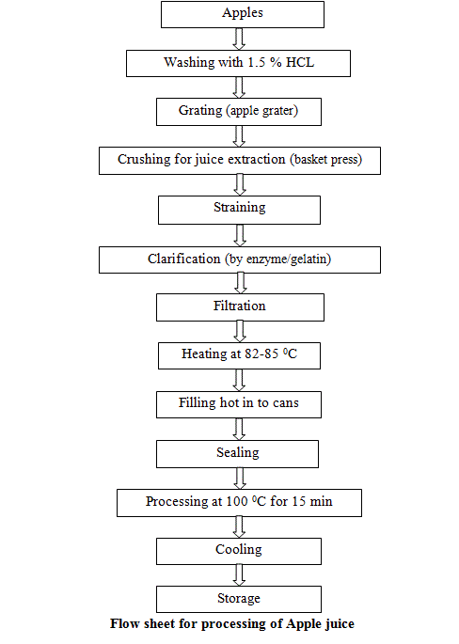

**9.11 Major challenges, constraints and concerns**

 - Despite policy initiatives, growth potential and significant achievements, there are several disturbing trends as delineated here:

 - In India, the value addition to food fortification is only 7% compared to as much as 23% in China, 45% in Philippines and 188% in the UK. The small-scale and unorganised sectors account for 75% of the total industry.

 - The basic problem associated with the industry is the sustained availability of suitable raw material for processing. Moreover, the productivity is also very low as compared to many other countries. The cost of raw material used for processing is 3 to 4 times more as compared to costs in the world market.

 - External liberalisation poses threats of stiffer competition under a new world trade order with WTO agreements relaxing quantitative restrictions and non-tariff/sanitary barriers on importing countries which exposes the Indian farmer to world market forces. Under the new trade regime, the food sector will be confronted by challenges of trade related Intellectual Property Rights, comprising patent laws, copyrights, trade links, etc.

 - The inherent strength of high raw material production and large domestic market base has to be buttressed with operating processing units at optimum capacity levels as per economies of scale which would enable achieving a competitive edge over imported products.

 - With the increasing competition from the international trade, quality of imported products will become more available in the developing countries. Therefore, to compete, the developing countries require proper post harvest management, distribution and processing chains. Hence, it is necessary to have better human resource capabilities in technology, management and marketing.

 - Advances in bio-technology have enabled production of Genetically Modified (GM) foods. These have already appeared in some countries. GM foods need be critically examined on their good and adverse impacts on human health.

 - Taxes on processed food in India are among the highest in the world. No other country imposes excise duty on processed food and distinguishes between branded and unbranded food sectors for taxation. There is excise duty of 16% in the form of CENVAT levied on food products. Besides there is sales tax, octroi, mandi samiti, entry tax and customs duty on material, levied by the Central/State/Local bodies. The net effect ranges from 21% to 30% on various food items.

 - Policies like participation of private sectors through contract farming and land leasing arrangement can assure supply of good quality raw material to the fruit and vegetable processing industry.

 - It is very vital to educate consumer about the processed fruit and vegetable based products and their nutritional quality.

 - Backward-forward integration from farm to processors and consumers and also to generate more employment to eliminate poverty.

 - Should have control over taxation with other nations during export and import of the processed fruit and vegetable products.

 - Commercial R&D activities in the food industry have remained confined to only a few areas. R&D activities have scarcely emerged from the laboratory to be extensively adopted on the field.

 - Indian brands have yet to acquire an image in the international markets because of poor global marketing.

- Most Financial Institutions lack capacity to appraise hi-tech export-oriented projects. There are no suitable insurance schemes for such projects, most of which deal in export of perishables. In financing such projects the banks face considerable credit risks. With new technology, the risk perception is higher than the existing one.

 The sector has been characterized by poor marketing, transport and communication infrastructure. The market density of fruits and vegetables is low and facilities for storage and cold chains in the hinterlands are woefully inadequate. Erratic and inadequate power supply, lack of roads, lack of quality water, education and health facilities and null or low rural industrialization accentuates the problems.